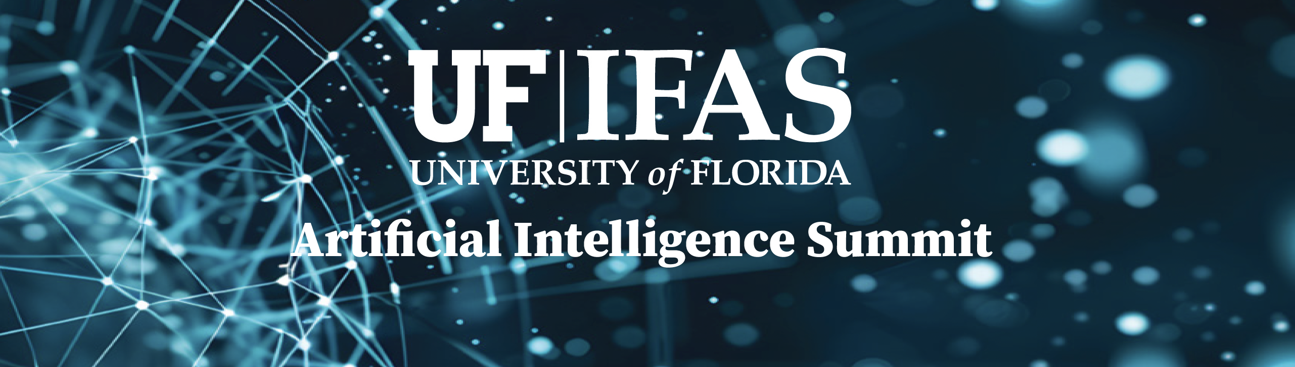
UF/IFAS Artificial Intelligence Summit
Emerson Alumni Hall, University of Florida
February 12, 2026
8:30 am Check-in, coffee & snacks
Morning Session: Setting the Stage & Sharing the Vision
9:00 - 9:15 am Welcome & Opening Remarks - UF/IFAS Senior Vice President for Agriculture and Natural Resources (Scott Angle)
AI and UF/IFAS Mission - UF/IFAS Dean for Research (Robert Gilbert)
9:15 - 9:30 am UF Vision for AI - Provost and Senior Vice President for Academic Affairs (Joseph Glover)
9:30 - 9:50 am Director of UF Artificial Intelligence and Informatics Research Institute (Alina Zare)
9:50 - 10:10 am UF/IFAS Applied AI Center (Jack Reckcigl)
Break 10:10 – 10:30 am
10:30 - 10:50 am Keynote talk: Towards Autonomous and Intelligent Crop Management Using AI and Robotics (Yiannis Ampatzidis)
10:50 - 11:10 am Keynote talk: Empowering Plant Phenomics with AI to Advance Crop Improvement (Charlie Li)
11:10 - 11:30 am Keynote talk: Frontiers in GeoAI and Earth Observation Modeling (Sabine Grunwald)
11:30 – 12:00 pm Lightning Talk Session 1 (Moderators: Ziwen Yu, Xiaoya Zhang)
- Haipeng Yu (Title: Leveraging AI-Derived Digital Phenotypes for Precision Dairy Farming)
- Daniel Hofstetter (Title: Applying Machine Learning to Understand Animal Behavior)
- Henry Medeiros (Title: TBD)
- Daeun Choi (Title: Digital Twins From Simulation to Field Deployment for Agricultural Automation)
- Bala Rathinasabapathi (Title: TBD)
Afternoon Session: Growing Our AI Footprint
12:00 – 1:00 pm Lunch & Poster Presentations (Moderators: Raquel Dias and Diana Taft)
Enjoy lunch while exploring cutting-edge research posters and networking with peers.

1:00 – 1:45 pm Panel 1: Translating AI Research into Commercial Impact
Explore pathways from academic innovation to market-ready solutions. Moderator: Kati Migliaccio.
Panelists: Bob Pitzer (HCR), Matt Donovan (AgIntel), Sarah Martello (Transparency Wise Technology), Kyle Norton (Everglades Equipment), Scott Berden (U.S. Sugar)

1:45 – 2:30 pm Panel 2: Navigating the AI Grant Funding Landscape Insights into funding opportunities and strategies for successful proposals.
Moderator: Damian Adams
Panelists: Angela Records (Chief Scientific Officer, Foundation for Food & Agriculture Research)
Irene Cooke (Asst. VP for Research and Interim Director, UF Research)

2:30 – 2:45 pm Break

2:45 – 3:30 pm Lightning Talk Session 2 (Moderator: Kevin Wang, Boce Zhang)
- Raquel Dias (Title: TBD)
- Nikos Tziolas (Title: Developing Trustworthy AI for Florida Agriculture)
- Won Suk (Daniel) Lee (Title: Strawberry yield prediction system using color imaging and artificial intelligence)
- Chang Zhao (Title: GeoAI for Bridging Ecosystem Service Research Gaps)
- Felipe Ferrao (Title: DeepFlavor: integrating computer vision and sensory analysis for flavor improvements)
- Carlos Messina (Title: AI-enabled predictive breeding: Sorghum case study)
- Katia Viana Xavier (Title: AI-Powered Plant Disease Management: From Early Detection to Decision Support)

3:30 – 4:15 pm Panel 3: UF/IFAS AI External Advisory Board – Strategic Insights
Perspectives from industry and academic leaders on advancing UF/IFAS AI.
Moderator: Robert Gilbert

4:15 – 4:30 pm Closing Remarks by UF/IFAS Dean for Research (Robert Gilbert)

